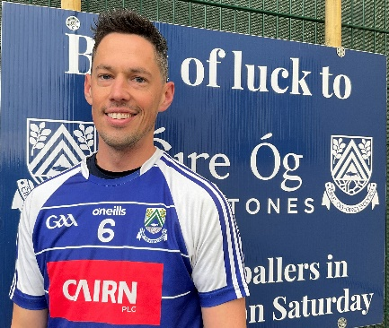 | MICK CANNON
Who has been your toughest opponent and why? | Diarmuid Connolly - two feet and too good.
Proudest day? | Scoring a point in the 3rd round this year - I didn’t know I could score points before then!
Toughest or most disappointing day in GAA? | When my mam asked me if I thought I was too old to still be playing!
Who has been the biggest influence on your career? | My dad and my juvenile coach.
Who is the joker on the panel? | James Woods - he looks like the Joker too.
Who is the best dressed? | Billy “Pink Shorts” Norman.
Who is the worst dressed? | Danny Woods - never wears trousers even when its cold!
What player from another sport do you most admire? | Seamus Coleman.
What manager from another sport do you admire? | Phil Jackson.

