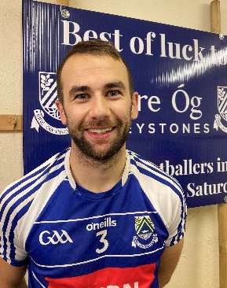 | DAN KEANE (C)
Who has been your toughest opponent and why? | Hollywood. We learnt a few lessons that day up in Roundwood. They Dominated us  from start to finish in what was probably our worst performance of the year and we  regrouped after and have kicked on since. It was a kick up the backside for us.
Team you most like to beat? | Traditionally from Juvenile ranks, it’s been Bray Emmets - the local derby. Growing  up through Underage teams that was the fixture we all loved to play. Some days we  lost and some we won, and it was always sweet when it was the latter.
Proudest day? | I think this upcoming final will be my Proudest day with the Club. Other great days  were being involved with the 2011 Leinster winning team and winning the Dunne Cup.  Its an honour to play for this club and I’m very fortunate I have been able to do it  since I was 6/7 years old. To be Captain of the team adds an extra bonus to it all.
Toughest or most disappointing day in GAA? | Personally, two of the toughest days were the defeats to Pats and Rathnew in the Semi  Finals of the Senior Championship in back-to-back years. Both went to replays and  we were up at half time in the games also and couldn’t close it out. They were tough  days to take.
Adult Championship debut? | 2012. Tipping on now….
Who has been the biggest influence on your career? | My Parents AND the numerous different coaches I have had from Juvenile to Adult level  Football.
Who is the joker on the panel? | I think I will have to give Sammy “Turbo” Thompson this one. I have never met a  man who gets to the Pub quicker after a game. They don’t call him Turbo for no  reason.
Who is the best dressed? | Danny Wood could wear a Bin Bag and he would still look great.
Who is the worst dressed? | I am going to have to give Fintan O Shea this one even though he will disagree.  Among a few questionable outfits, He was wearing a pair of baggy khaki pants one  day. There was a gust of wind I thought he was about to take flight. Also, Special  Mention here to my brother Peter Keane who once rocked a pair of Copa Mundial  boots on the Foundry dancefloor in Carlow.
What player from another sport do you most admire? | Tiger Woods. To be competing at the top table for so long is admirable and to this  day would still be the biggest draw in his sport after decades of playing. He changed  the game of golf for so many who came after him.
What manager from another sport do you admire? | Sir Alex Ferguson. As a Man Utd fan, this was the obvious choice.

