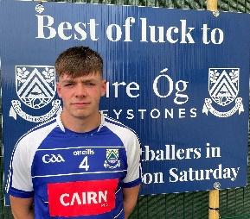 | Fionn O’Carroll
Who has been your toughest opponent and why? | Eamon Rossiter, almost takes my ankles every time we play Coolkenno.
Proudest day? | Probably winning a Minor A or beating the Dubs in Parnell Park.
Toughest or most disappointing day in GAA? | Either getting relegated last year or losing a Leinster semi replay to Kildare, both hurt  Bad.
Adult Championship debut? | 2019
Who has been the biggest influence on your career? | Probably my dad to be fair.
Who is the joker on the panel? | Has to be Petey Keane.
Who is the best dressed? | I reckon Conall Deeney would be a good shout.
Who is the worst dressed? | Definitely seen Finto O’Shea with some questionable garms on!
What player from another sport do you most admire? | Toss up between Leo Messi or Michael Jordan.
What manager from another sport do you admire? | Jose Mourinho holds a special place in my heart and in his prime was untouchable.

